UL Homer Pro Modelling the Thacher School MicroGrid

11/20/23

Contents

Task 1

Executive Summary 1

Background 2

Technical Characteristics 2

Modelling the Existing System with Grid Connection 2

Load Modelling 2

Load Determination 3

Components 4

Solar 4

Converter 5

Storage 5

Existing System Model Analysis 7

Solar Production 7

Battery Storage 7

Analysis of Expanding the System 8

Expanding Solar by 25% 8

Expanding Battery Capacity by 25% 9

Shifting daily loads 9

Conclusion: 10

# Task

Simulate the Thacher Boarding School’s Microgrid in Ojai California with UL Homer Pro (Homer). Identify the daily load it can handle and assess the impact of increasing the solar capacity 25%, battery capacity 25%, or reducing loads during non-sunlight hours.

# Executive Summary

The existing system has enough yearly solar generation to produce electricity equivalent to about 90% of the school’s overall electricity usage. However, the system can only provide and supply about 10% of the school’s usage on cloudy days. Small increases to solar capacity, battery capacity, and shifting the loads have minimal ability to change this amount. In the event of grid disconnection, an intentional push to carry out electric functions during sunlight hours and on sunny days is the most effective route to harvesting the available solar energy.

# Background

The California Energy Commission published a report on microgrid case studies in 2018 which can be found at the following url:

<https://www.energy.ca.gov/publications/2018/microgrid-analysis-and-case-studies-report-california-north-america-and-global>

The Thacher School is one of the case studies reported and the Project Background is reported as follows:

“The Thacher School is an independent boarding school with approximately 250 students, located in Ojai, California. Sustainability and power resiliency are important to the school. The school is located near the end of a remote utility feeder and suffered a major outage of 10 days due to wildfires in 2007. The microgrid is a solar-plus-storage system that can island from the grid during outages.”

## Technical Characteristics

* 750 kW solar PV (265 W panels), Kyocera
  + $3,400,000 for the PV System.
  + $250,000 for permitting and related costs
* 250 kW Li-ion battery and microgrid controls, JLM Energy Gridz
  + $580,000 for storage and microgrid controls
  + $100,000 for additional surveys and related costs.
* 90% of the electricity is currently provided through solar, or around 1.2 million kilowatt-hours each year.
* Previous simple payback period: 18 years.
* Installed batteries and solar in 2016 and 2017.

# Modelling the Existing System with Grid Connection

## Load Modelling

* A standard “Community” load will be assumed. This load contains a usage increase at the end of the day from 6 p.m. to 9 p.m. while seeing an otherwise relatively level load starting around 7 a.m.
* The school year starts with faculty returning August 16th and the school closing for the summer May 30th. We will consider the summer break to run from June 1st to July 31st and the energy load to be 50% of normal during this time. This can be modelled in Homer by reducing the daily values for those months by 50% compared to non-break months.

**Figure 1:** Pictures of the load data for June and July being reduced 50% compared to the rest of the year for summer break. Homer scales these values to an overriding daily electric usage value. The heat map additionally shows the electric energy usage throughout the day with usage ramping up around 6 a.m. and peaking around 7 p.m.

* The normal existing load will be considered to be 1.33 million kilowatt-hours a year or 3,641 kilowatt-hours a day on average.

## Load Determination

* A sensitivity analysis around the “Scaled Annual Average (kWh/day) will be used to investigate the current load the system can sustain without connection to the grid.

**Figure 2:** Values used for the sensitivity analysis to determine the maximum daily load the system can support. These are the final simulated values after trial and error of a wider set of values was initially used.

* To simulate the system in the event of disconnection from the grid pre-programmed constraints need to be removed. In the Constraints Section all of the Operating Reserve Values are manually set to 0.

**Figure 3:** Operating reserve constraints are modified to simulate disconnection from the grid. Homer defaults require an excess of renewables generation which would discount the available energy rating in event of grid disconnection.

## Components

### Solar

* The coordinates for the existing solar panels are at 34.463977, -119.176939.

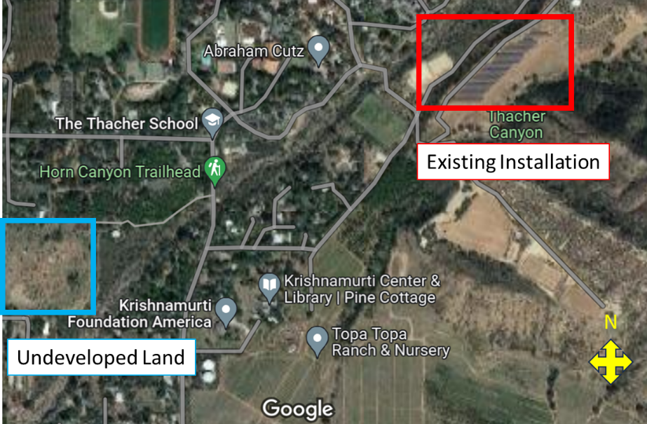

**Figure 4:** Google Maps view of the school and proximity to the solar panels. The solar panels are next to hills and are likely designed around shading considerations from the hills. A small expansion of the system at that site may be possible. If not, there appears to be other undeveloped land in the vicinity.

* Since no information on what type of PV panels were installed we will use the “Generic flat plate PV” Option in Homer with default settings. This includes an 80% derating factor. The “Search Space” will be restricted to 750 kW in order to force the simulation of this system.

**Figure 5:** Restricting the Search Space for the system forces the simulation of the existing system.

* Multi-Year Inputs will be used in order to assess the productivity of the solar panel with time. A value of -0.5% per year is assumed. This value results in a similar 12th year degradation as Silfab SIL-430 BG+ panels (https://silfabsolar.com/wp-content/uploads/2023/09/Silfab-SIL-430-BG-Data-Generic-20230906-Final.pdf)

### Converter

* The electrical architecture was not specified so Homer Optimizer is used to size an appropriate size DC-AC Converter for the system. This was first carried out with the Multi-Year Modelling turned off since Multi-Year cannot run with the optimizer. Homer recommended a converter size of 34.4 kW for the maximum load system. This was then manually added in via the Search Space option and Multi-Year Modelling was turned on.

### Storage

* JLM Energy Gridz is no longer active and no further information on the batteries was provided.
* Similar systems to that used in this project can be found in the Homer “Complete Catalog”. For example, the system will be modelled similar to the SAFT Intensium Max Plus 20M ESSU[Kinetic] system. The data sheet link in Homer has expired but the stored parameters in Homer describe a system as:
  + Nominal Voltage (V): 720V
  + Nominal Capacity (kWh) 55
  + Maximum Capacity (kWh): 76.4
  + 70% degradation at end of life

**Figure 6:** Homer Catalog Entry for SAFT Intensium Max Plus 20M ESSU[Kinetic] as an example of a comparable battery system.

* Without further information, we will assume battery degradation similar to that quoted in the Saft Intensium Max+ 20M (1.1 MWH-2.5MW) data sheet which can be found at <http://www.efo-power.ru/datasheet/Saft/System/IM_20M.pdf>. That being 20% degradation at 3,600 cycles. We will assume one battery cycle a day has been carried out through the batteries’ lifetimes and 7 years usage so far. This puts the batteries at ~2,500 cycles. This means the original 250kW system will now be approximately 210kW nominal and will be modeled as such.
* For greater control over the battery characteristics, a “Generic 1kWh Li-ion” Battery was used as a template for modelling in Homer. 1 string of 105 batteries provide a 630V System with 105kWh capacity. 2 strings provide a 630V system with 210kWh nominal capacity.

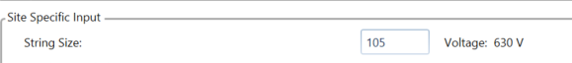

**Figure 7:** Inputs to “Generic 1kWh Li-ion” template in Homer to create our aged battery pseudo-system.

* With more information on the batteries, a detailed battery model could be made by modifying copied battery models in the Homer library.
* For connection to the grid we will also assume that the minimum SOC for the batteries can now go to 0% instead of the Homer pre-programmed value of 20%.

Homer predicts that the system will only be able reliably handle an equivalent load of about 300kWh a day in the event of disconnection from the grid. This is represented by Homer providing successful simulations for 300kWh/d load but not 325kWh/d load. This is less than 10% of the normal electrical load from the school and is specifically due to the limited capacity of the batteries and variable nature of solar energy.

## Solar Production

Homer predicts a total solar production of 1,279MWh a year with a mean solar output of 3,506kWh a day. This is very close to the average school’s electrical usage of approximately 3,600kWh a day. However, solar energy is variable and there are days with relatively little sunlight which bring down the rated daily load capability. The figure below shows days with little solar production (March 26th) right next to days with much higher solar energy production (March 27th). Homer restricts its load rating so that the load is covered even on days with low solar output.

**Figure 8:** Homer simulated solar production day-by-day for the end of March. Solar output is variable and the system is constrained by low production days such as March 27th.

## Battery Storage

Homer calculated 51,256 kWh/yr provided from the batteries, or approximately 140kWh a day on average at this stage of life. This is impacted by the minimal load in the summer with batteries not fully charging and discharging during those times. For non-summer months Homer predicts frequent full charge and discharge of the batteries’ approximately 210kWh.

**Figure 9:** Heat map of the state of charge of the batteries for a system operating at 300kWh/day on average. Homer shows frequent complete discharge of the batteries illustrating it is fitting the system so that at the edge of the batteries’ capabilities.

# Analysis of Expanding the System

## Expanding Solar by 25%

A value of 940kW rated solar capacity was selected in the Generic flat plate PV Tab’s Sizing Search Space to simulate a 25% increase to the solar capacity. Solar generation correspondingly increased to 1,604MWh a year but did not significantly increase the load capability of the system in the event of grid disconnection. System with 300kWh/d for load had solutions while 325kWh/d did not. Thus, the increase in load capability is less than 25kWh/d. The benefit of the increased solar production is reduced by the load trailing past solar generation times. The graph below shows the trailing energy usage past the sunlight hours which restricts the load rating.

**Figure 10:** Solar production and load curves with 25% increased solar production. 25% solar does not lead linearly to 25% higher rated load due to the load trailing past the solar generation hours.

## Expanding Battery Capacity by 25%

25% extra capacity will be added based on the original 250kWh battery rating system. This can be roughly estimated by adding 31-1kWh batteries each to the existing two pseudo-strings in the simulation. In reality, it is likely an existing system expansion would not simply add new batteries in series. However, this is the most convenient method of adding capacity due to Homer Pro’s trouble with simulating multiple different battery banks.

This increases the feasible rated load in Homer up to 375 kWh/day and, slightly higher overall than 10% of the school’s normal load. This is due to better capability to supply the trailing load discussed previously.

**Figure 11:** Solar and load curves with increased battery capacity. Larger loads are possible in such situations.

## Shifting daily loads

Several different load profiles were tried in Homer aimed at shifting the load to peak sunlight hours. Examples are shown below (before scaling). No modified profile was able to significantly increase the rated daily load in Homer.

**Figure 12:** Custom Load profiles investigated ot determine if shifting the load peaks could allow a larger rated load.

This result is due to the variable nature of solar panel. Even in sunny California there are a few days every year with little sunilght. Shifting a load to a more sunlight friendly hour is not effective when the sun is not shining then.

# Conclusion:

The Thacher School Microgrid system has a panel solar system appropriate to generate the school’s approximate net energy consumption for a given year. However, the battery bank is effectively only appropriate for emergency functions in the event of disconnection from the grid. The variable nature of solar and battery bank size only allows the system to secure about 10% of the school’s normal electrical usage in the event of disconnection from the grid. If further electrical utilization is needed then electrical functions will need to be scheduled around sunlight hours and sunny days.